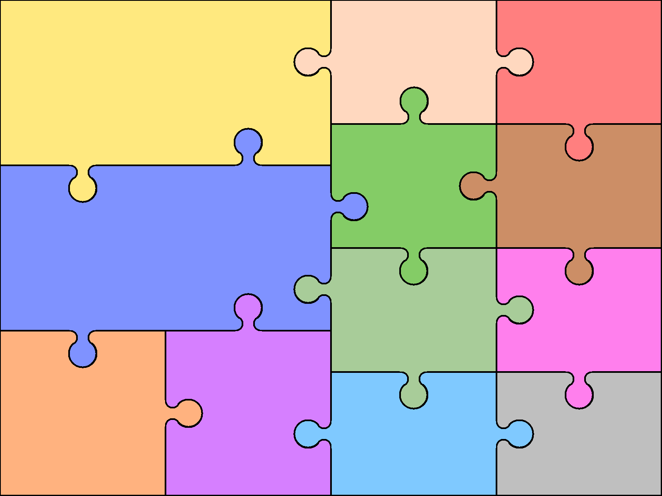
THEME JIGSAW THEMES: Stone Age / Magical Kingdom YEAR GROUP:3 TERM: Autumn
Science
I will group together different kinds of rocks on the basis of their appearance and simple physical properties; identify materials on the basis of whether they are attracted to a magnet and compare how things move on different surfaces. I will develop my understanding and use of scientific vocabulary.

Maths
I will count in hundreds; identify the value of each digit in a three-digit number; compare and contrast numbers up to 1,000; read and write numbers in numerals and words and solve number problems and practical problems. I will add and subtract numbers mentally; add and subtract numbers using formal written methods of columnar addition and subtraction; estimate the answer to a calculation and use the inverse to check answers and solve problems including missing number problems. I will recall number bonds within 20 and recall multiplication facts for the 3 times table.
English
I will consolidate and further expand the range of words I can spell accurately, including words with suffixes and prefixes. I will learn to use a broader range of adjectives and apply basic punctuation accurately. I will use conjunctions,
adverbs and prepositions to express time and cause in my writing. I will write more complex sentences; use ‘a’ or ‘an’ in front of a noun; make notes about what I will write about, and organise my writing using headings, settings, characters and plot. I will edit my work, begin to make improvements and read my writing out to an audience in a clear manner.

PE
I will create
dance moves and evaluate, compare and improve my performance. I will play a range of target and invasion games, developing a range of skills; understand the rules and
play a game of hockey.

RE
I will investigate what Christians
learn from the creation story
and what it is like for someone
to follow God.
PSHEC
I will learn about responsible choices and seeing things from others’ perspectives.
I will celebrate differences and understand ways to manage conflict.
Computing
I will develop my understanding of
computers and networks and
design, create and edit an
animation.

Art and Design
I will learn about and try to recreate Stone Age art. I will experiment with different forms of media when adding colour to a picture. I will make careful observations and detailed
sketches.

Design and Technology
I will make realistic plans; think ahead about the order of my work; select the most appropriate tools and
techniques to make my
design and compare ideas in my own and others’ work.

History/Geography
I will use a timeline to place events; ask questions about and use evidence to describe life in the Stone Age and present
my findings about the past in
different ways.
I will identify and locate specific
places and features using atlases and
maps and describe and explain strategies to support endangered species.
Music

I will listen to pieces of music and express it in different ways.
French
I will learn to say the date and when my birthday is; identify and select classroom equipment and colours and express my feelings and opinions.

