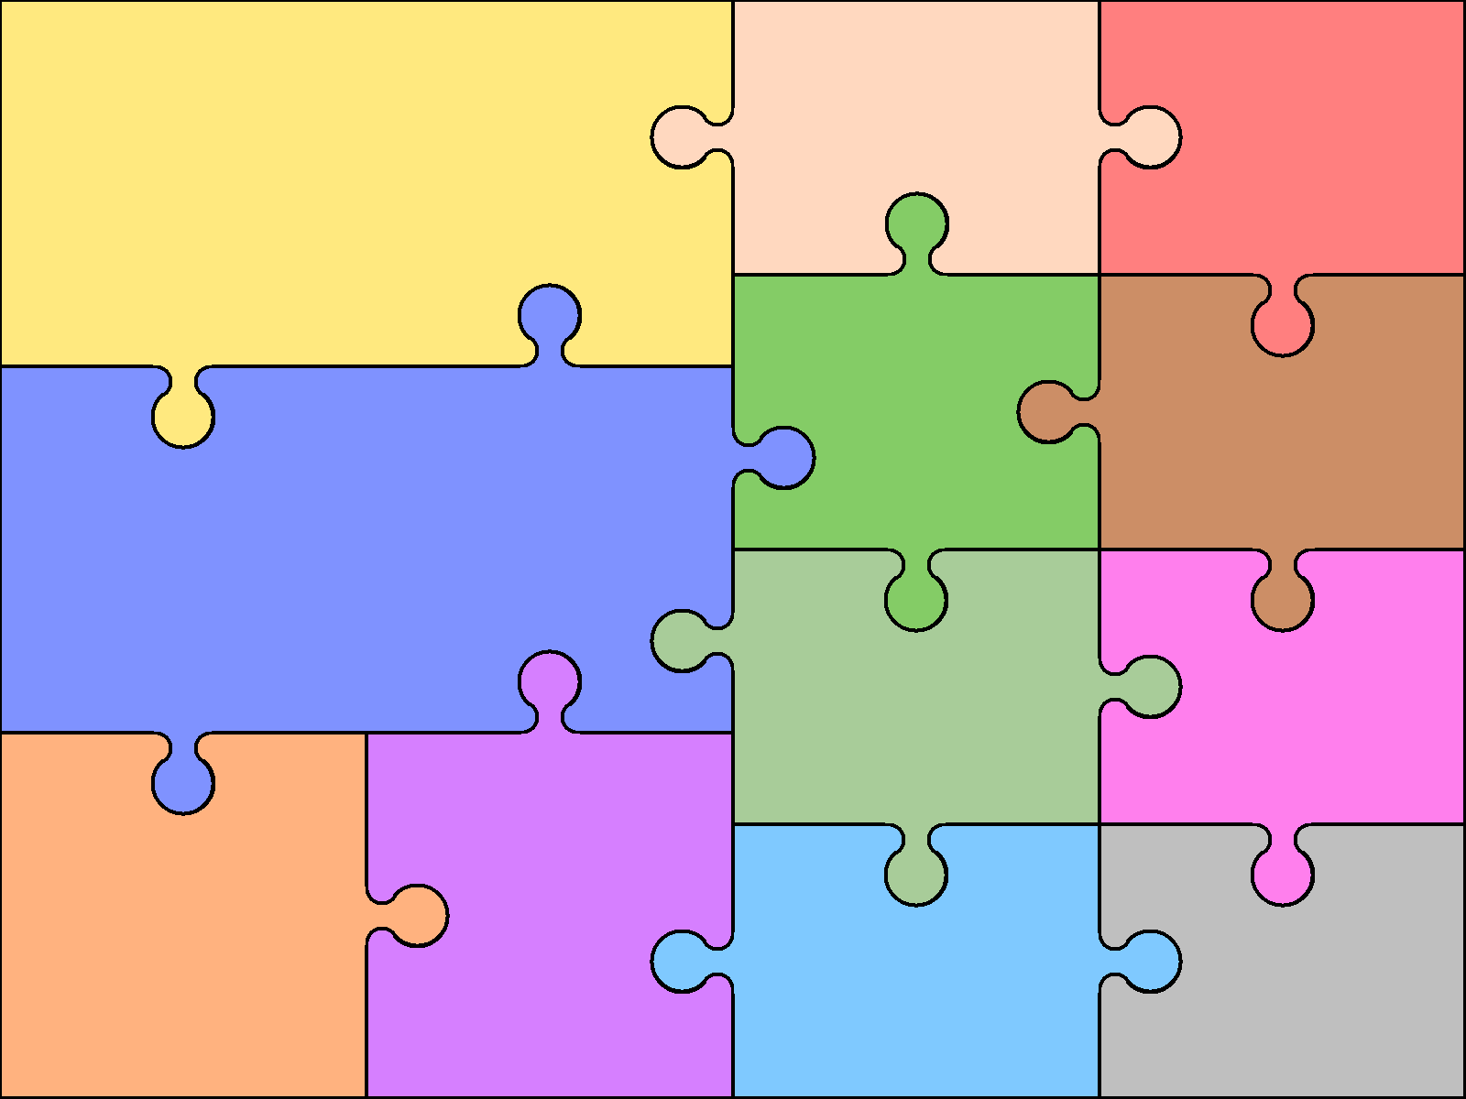

**Art and Design**

**I can use different media to create different portraits.**

**Year 2 Autumn Term: We Are All Superheroes!**

**PSHE - Jigsaw**

**Being Me in My World**

**PE**

I can aim, send and receive a ball.

I learn and apply rules and tactics of a game & talk about my own and others’ performances.

I plan and control sequences of movements to music.

**Computing**

I can tell you what ‘technology’ is and where we may use it.

I can tell you how to keep safe when using technology.

**Science**

I explore and compare the differences between things that are living, dead, and things that have never been alive

I can describe the importance for humans of exercise, eating the right amounts of different types of food, and hygiene.

**Music**

**I can sing and perform.**

**I can use percussion instruments to improvise and compose.**

**RE**

**Who is Muslim and how do they live?**

**Geography**

I can recognise that the food I eat comes from plants or animals.

I can identify the main geographical features of the physical landscape.

**Maths**

I can compare and order numbers from 0 to 100.

I can use place value and number facts to solve problems.

I can use the < > = signs correctly.

I can count in steps of two, three and five from 0 and in tens from any number, forward and backward.

**English**

I can use senses to describe.

I can write clear sentences using nouns, adjectives and verbs.

I am beginning to use conjunctions to join ideas.

I can read some common exception words.

I can read aloud with increasing fluency.

I can answer questions and make simple inferences.