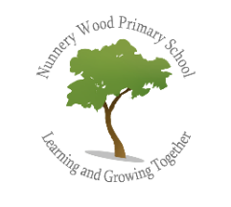
Art & Design at Nunnery Wood Primary School

Intent – What we are trying to achieve?
Art and Design embody some of the highest forms of human creativity. It is our intention to provide a high quality art and design education that should engage, inspire and challenge pupils, equipping them with the knowledge and skills to experiment, invent and create their own works of art, craft and design. As pupils progress, they should be able to think critically and develop a more
rigorous understanding of art and design. They should also know how art and design both reflect and shape our history, and contribute to the culture, creativity and wealth of our nation.

At Nunnery Wood our Art & Design curriculum aims to ensure that all pupils:
- produce creative work, exploring their ideas and recording their experiences.
- become proficient in drawing, painting, sculpture and other art, craft and design techniques.
- evaluate and analyse creative works using the language of art, craft and design.
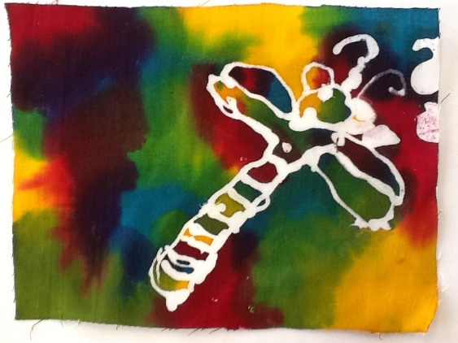
- know about great artists, craft makers and designers, and understand the historical and cultural development of their art forms.

Implement – What does Art & Design look like at NWPS?
At Nunnery Wood Primary School we ensure that when teaching:
- Children have opportunities to handle and experience a variety of different tools and materials.
- Children are encouraged to experience a variety of approaches and techniques.
- Children have opportunities to work in two and three dimensions.
- Children have experience of the different starting points for their work. The three main starting points for art work are: first hand observation, experience (memory) and imagination.
- Children have experience of working on a variety of scales. When working on a large scale children are encouraged to work collaboratively.
- Children have experience of working independently and in groups on art projects.
- Children have opportunities to extend their experience through the opportunity to participate in ‘art weeks’, including the chance to work alongside artists and craftspeople.

It is important that children develop their knowledge of the language of art, i.e., line, colour, tone, texture, pattern, shape, space, composition and form. This is done through the making of images and objects, and through talking about and studying the work of other artists. Children should become familiar with this vocabulary and are encouraged to use these words to talk about their work and the work of others.

Teachers ensure that children experience a range of skills and techniques including; drawing, painting, sculpture, print making, collage, textiles and digital media. They also seek opportunities to use a wide range of artwork, including prints and artefacts; visits to galleries/museums and visitors to the school, to enhance and enrich the learning that we provide for the children.
How is Art & Design linked to other areas of the curriculum at NWPS?
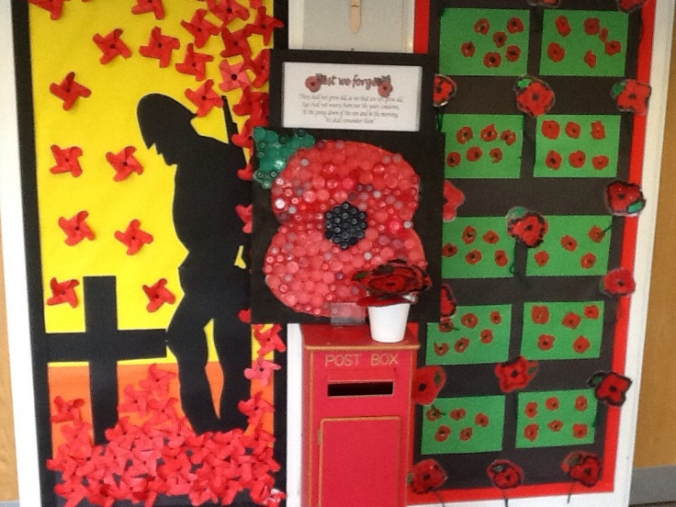
Often, work in Art will have cross curricula connections, notably History, Geography, Design and Technology, Computing and RE. Teachers at NWPS ensure that these opportunities for linking Art with other subjects are maximised.
Strong links are promoted between Art and English through the use of visual literacy and practical activities that stimulate and enhance children’s writing.
In Art children are encouraged to use materials to express their own feelings, ideas and values. Works of art are used as a stimulus and for pupils to discuss and compare how other artists express their own ideas and feelings. This opens up many opportunities for developing children’s personal, social and cultural development. These opportunities are maximised by special events, activities and visits.
How is the teaching and learning of Art & Design organised at NWPS?
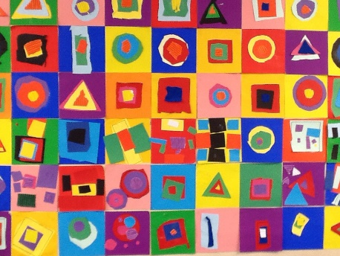
The scheme of learning used at NWPS follows the National Curriculum.
The youngest children in Early Years are encouraged to represent their thoughts and feelings in different ways as according to the Early Learning Goals. Our skills progression document, based on the National Curriculum, is used as guidance for teachers in KS1 and KS2 to ensure that all skills are covered over a two-year period.

