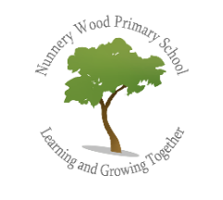
Music at Nunnery Wood Primary School
Intent – What we are trying to achieve?

Music plays a very important part of our school life. Our intention is that every child grows a love of music which goes on with them beyond school and that Music is fully embedded in different aspects of school life. Music, here, is interactive and fun with the aim to foster a love for the subject, building on skills from Foundation Stage through to Year 6 and bringing us all together as a community.
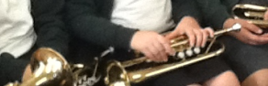

Children have the opportunity to learn a variety of different instruments with various peripatetic teachers. In Year 4 children learn to play an instrument as part of the music curriculum. This is an enriching opportunity which we believe all children should participate in by the end of KS2 (see school charter).

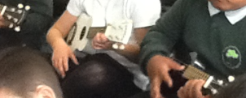

Our children develop their confidence as they learn to work independently and as part of a team/class. Each year group presents a show/concert each year which are very well supported by our parents and community. The children also have the opportunity to take up lessons provided by private tutors in piano, violin, keyboard, guitar, clarinet and cornet.
Implement - What does Music look like at NWPS?
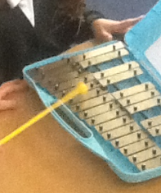
Music is often linked to the topics taught in class and can be used to develop skills in English and Maths. It is taught in line with the National Curriculum and builds on progression each year. Songs are taught in different languages and music is celebrated from different cultures. The children have opportunities to participate in singing, playing tuned and un-tuned percussion instruments as well as listening to live and recorded music. In KS2, the children have an opportunity to compose and listen to their own music, and learn the correct musical notation and terminology, eg. rhythm, melody, pitch and dynamics.
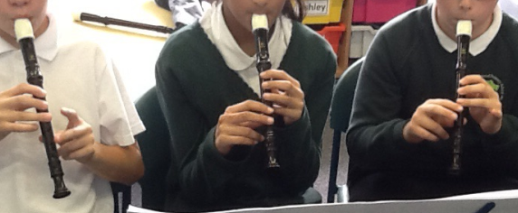

Weekly singing assemblies take place to teach children how to sing with a sense of pitch and melody. They are taught how to warm up their voices, sing in rounds and harmony, and build up a repertoire of songs. We have a school choir which meet each week and perform at whole school events and in the local area, for example, local care homes. The children have opportunities to listen to live music, for example, from visitors such as the children at Kings School Worcester and our peripatetic teachers also provide live performances encouraging children to take up an instrument. They have the opportunity to take part in live performances such as ‘Young voices’ and ‘Big sing’.

Impact - What does success look like?
At Nunnery Wood Primary School we aim to develop an understanding of Musical Concepts and to develop practical skills, enabling children to respond and communicate musical ideas, thoughts and feelings. Opportunity is also given to develop an awareness of musical traditions, styles and cultures.
Music in our school allows all children to participate with enjoyment in the activities of singing, playing (tuned and untuned instruments), composing/Improvising, listening, and performing.
Through these activities children will develop an understanding of musical concepts such as pitch, duration, dynamics, tempo, timbre and texture.

EYFS: | • Exploring and using media and materials - children sing songs, make music and dance, and experiment with ways of changing them. They safely use and explore a variety of materials, tools and techniques, experimenting with colour, design, texture, form and function.  • Being imaginative - children use what they have learnt about media and materials in original ways, thinking about uses and purposes. They represent their own ideas, thoughts and feelings through best practice and activity ideas.
Key Stage 1 | - use their voices expressively and creatively by singing songs and speaking chants and rhymes 1.1  - play tuned and untuned instruments musically 1.2  - listen with concentration and understanding to a range of high-quality live and recorded music 1.3  - experiment with, create, select and combine sounds using the inter-related dimensions of music. 1.4
Key Stage 2 | - Pupils should be taught to sing and play musically with increasing confidence and control. They should develop an understanding of musical composition, organising and manipulating ideas within musical structures and reproducing sounds from aural memory.  - play and perform in solo and ensemble contexts, using their voices and playing musical instruments with increasing accuracy, fluency, control and expression 2.1  - improvise and compose music for a range of purposes using the inter-related dimensions of music 2.2  - listen with attention to detail and recall sounds with increasing aural memory 2.3  - use and understand staff and other musical notations 2.4  - appreciate and understand a wide range of high-quality live and recorded music drawn from different traditions and from great composers and musicians 2.5  - develop an understanding of the history of music. 2.6

