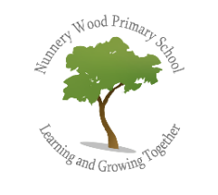
History at Nunnery Wood Primary School
Intent – What we are trying to achieve?

At Nunnery Wood primary School we engage pupils with a relevant, exciting, and challenging History curriculum which inspires curiosity and is appropriate for preparing them for an adult life in the 21st century. History teaching is essential since it:
- Helps the learner to understand the complexity of people’s lives, the process of change, the diversity of societies and relationships between different groups, as well as the challenges of their time;
- Develops skills of critical thinking which means making reasoned judgements that are logical and well thought out and not merely accepting arguments and conclusions as they are presented but having a healthy, discerning and questioning attitude about new information;
- Supports the learner to appreciate that all knowledge is socially constructed and its objectivity and reliability is therefore open to challenge and question through asking perceptive questions, weighing evidence, sifting arguments and developing perspective and judgement;
- Builds a sense of identity and belonging on a personal, cultural, national and global level as learners come to appreciate the diversity of human experience and consequently understand more about themselves and as members of society;
- Enables the learner to understand core concepts and most notably cause and consequence, similarity and difference, continuity and change, change and progress/regression, significance, evidence, chronology, empathy, context, diversity, perspective, interconnectivity and validity which have broad relevance and significance in the modern world;

What does History look like at NWPS?
In our History lessons, learning is facilitated through pupils pursuing a key question led enquiry approach, which encourages them to take increasing responsibility for their learning, think independently and achieve challenging subject outcomes. At NWPS therefore we seek to encourage pupils to learn their History through big question led enquiries about significant events, people and changes which allows them sufficient scope and time to really engage in high order subject skills such as developing explanations (even though there are very often no ‘right’ answers to questions in History), reaching conclusions, making judgements, evaluating, applying information learned in one context to another and generating their own ideas and questions to investigate through hypothesising. Whilst knowing more subject information as the pupils progress through the school is important we are careful in our planning to ensure that there is always a balance between new content and the development of important subject skills and the ability of children to think critically about what they are learning and why. This approach is reflected in all our planning. We are very careful to be selective about the subject content we use to ensure that a balance is achieved between knowing more content and the development of key subject skills and outcomes. Pupils record their work in a variety of ways, including diagrams, illustrations, pictures, letters, posters, annotated drawings and maps, reports, PowerPoints and oral accounts and presentations of their work. Most History learning forms the basis of a wider theme for that half term and is introduced with a ‘Wow-in’ and concluded with a ‘Wow-out’ at the end of the unit. These events often include a themed day of the historical period with staff and children coming to school in costume and experiencing a range of related activities.
What History is taught at NWPS?
At the end of Key Stage 1 our expectation is that all pupils will possess an awareness of some of the ways in which historians find out about the past. They will have shown as well that they can ask and answer simple questions about historical sources to help them learn about people and key features of events that they have studied. Pupils will also demonstrate that they can use simple and appropriate historical words and phrases correctly and have established a sense of chronology and change both in relation to their own lives and that of the country of the United Kingdom.
Across KS1 we aim to provide experiences of:
- changes within living memory and where appropriate, these are used to reveal aspects of change in national life
- events beyond living memory that are significant nationally or the lives of significant individuals in the past who have contributed to national and international achievements.
- comparisons of aspects of life in different periods
- significant historical events, people and places in our locality
The key skills taught across KS1 are the ability to:
- Recognise
- Identify
- Describe
- Observe
- Select
- Categorise
- Classify
- Sequence
- Connect and make links
- Compare and Contrast
- Recall
- Reason/Speculate
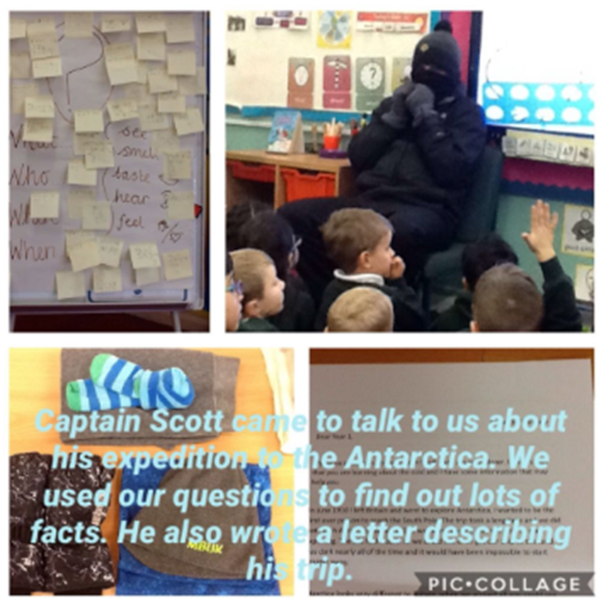
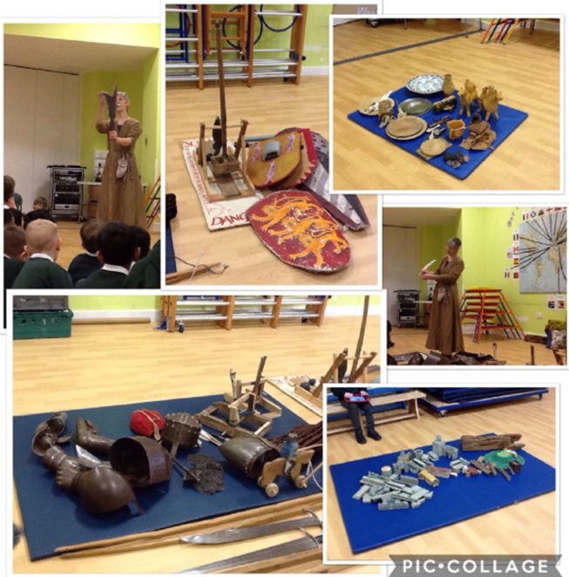
At the end of Lower Key Stage 2 our expectation is that all pupils will have developed a more sophisticated knowledge of the events and the lives of people in the past that they have studied, compared with that at Key Stage 1. In particular they will have shown that they can use a broader range of historical sources of evidence to help them construct and organise knowledge and to begin to explain (rather than just suggest reasons for) the processes of change and the actions of people and the causes of events. In doing so it is our expectation that our pupils will learn and apply appropriate and increasingly specialised subject vocabulary and phrases correctly to make informed responses and demonstrate a stronger sense of chronology and sense of identity.
Across LKS2 we aim to provide experiences of:
- changes in Britain from the Stone Age to the Iron Age
- the Roman Empire and its impact on Britain
- the Viking struggle for the Kingdom of England.
- the achievements of, and an in-depth study of the Ancient Egyptians
The key skills taught across LKS2 include all KS1 skills plus the ability to:
- Summarise
- Synthesise
- Construct informed responses
- Interpret and explain
- Demonstrate understanding

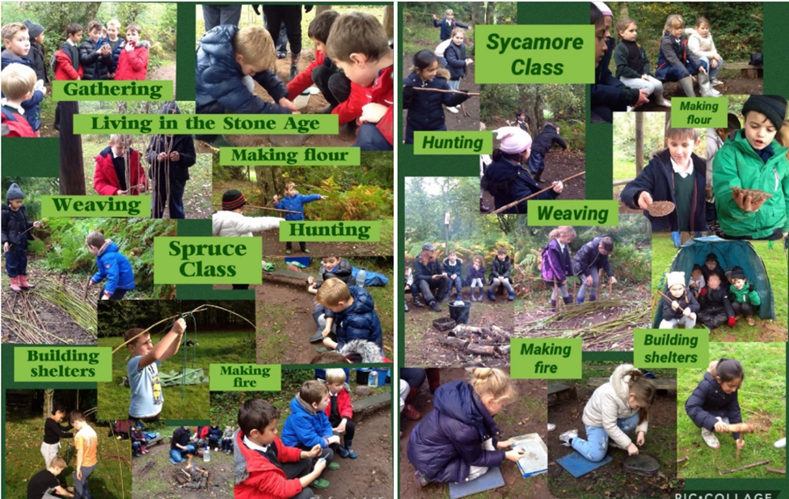

At the end of Upper Key Stage 2 our expectation is that all pupils will have demonstrated that they can interpret and evaluate more complex sources of evidence to reach conclusions and make judgements, which they can justify, about events and the actions of people in the past. In doing so they will understand and apply correctly specialised subject vocabulary. In constructing knowledge pupils will indicate that they understand that different arguments and perspectives surround the changes caused by events or people in the past and that the meaning or significance that people attach to such changes will vary.
Across UKS2 we aim to provide experiences of:
- a local history study
- studies of an aspect or theme in British history that extends pupils’ chronological knowledge beyond 1066 – the Victorians, and WW2.
- Ancient Greece – a study of Greek life and achievements and their influence on the western world
- a non-European society that provides contrasts with British history – Mayan civilization c. AD 900
The key skills taught across UKS2 include all previous skills plus the ability to:
- Empathise
- Reach Informed Conclusions
- Make reasoned Judgements
- Reflect
- Justify
- Apply
- Evaluate
- Critique
- Hypothesise – devise historically valid enquiry questions

Our key questions are:
NWPS History Overview
Year Group | Autumn | Spring | Summer
Year 1 | Why was Grace a hero? | What mistakes did Scott make?  Why do we have castles? | What does it take to be a great explorer?
Year 2 | Why do we have fireworks on November 5th?  Who is the greatest history maker? | Why did Samuel Pepys bury his cheese?  Why is the history of my locality important? | How did Darwin change the way we think about the world?
Year 3 | How did the lives of ancient Britons change during the Stone Age?  What is the secret of the standing stones? |  | How did the arrival of the Romans change Britain?
Year 4 | Why was the river important to the Egyptians? |  | What did the Vikings want and how did Alfred help to stop them getting it?
Year 5 | Why was Worcester called The Faithful City? | What did the Victorians do for us? | The story of The Trojan Horse: historical fact, legend or classical myth?
Year 6 | Why did the ancient Maya change the way they lived? | Why was winning the Battle of Britain in 1940 so important?

