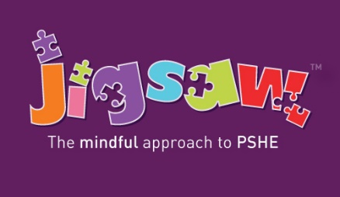
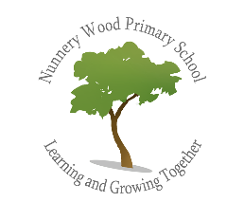
PSHE at Nunnery Wood Primary School

Intent – What we are trying to achieve?
At Nunnery Wood Primary School our intention is to provide a broad and balanced personal, social, health and economic education (PSHE) curriculum which results in the acquisition of knowledge and skills for life. These skills will prepare our pupils for the opportunities, responsibilities and experiences of later life. Our PSHE curriculum will;
- prioritise physical and mental health and wellbeing by providing pupils with skills to evaluate and understand their own wellbeing needs, encourage them to practice self-care and know how to contribute positively to the wellbeing of those around them

- encourage our pupils to develop their sense of self-worth and become active citizens by contributing to school life and the wider community

- equip pupils with a sound understanding of risk and with the knowledge and skills necessary to make safe and informed decisions in order to stay safe and healthy, including on-line safety

- enable our pupils to understand how they are developing personally and socially and tackle many of the moral, social and cultural issues that are part of growing up as well as develop their identity

- provide our pupils with opportunities to learn about rights and responsibilities and appreciate what it means to be a member of a diverse society

- enable pupils to build and maintain successful relationships

Implementation - What does PSHE look like at NWPS?
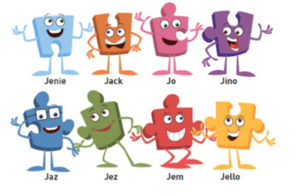
We are mindful that the delivered curriculum must reflect the needs of our pupils therefore teachers will use and adapt the Jigsaw PSHE programme according to their pupils and their diverse needs. By using Jigsaw, Nunnery Wood Primary School will deliver an engaging, relevant PSHE curriculum as a whole-school approach with each year group working on the same theme (a puzzle) throughout the academic year. It is seen as a vital part of primary education and is taught in classes, weekly by the class teacher. By using Jigsaw, we will provide a comprehensive programme of PSHE as a spiral, progressive approach. Revisiting themes will enable our pupils to recall and build upon previous learning, exploring the underlying principles of PSHE education regularly at a depth that is appropriate for their age and stage of development. Jigsaw holds children at its heart and its cohesive vision helps pupils understand and value how they fit into and contribute to the world, it also has a strong emphasis on emotional literacy, building resilience and nurturing mental and physical health. Jigsaw lessons also include mindfulness allowing pupils to advance their emotional awareness, concentration and focus. Using Jigsaw will ensure the pupils of NWPS develop the vocabulary and confidence needed to clearly articulate their thoughts and feelings in a climate of openness, trust and respect and know when and how they can seek support.

Impact - What PSHE is taught at NWPS?
Jigsaw consists of six half-term units of work (Puzzles), each containing six lessons (Pieces) in each year group. Puzzles are linked to our School Values, British Values, rights and responsibilities and Growth Mindset so that pupils have depth and breadth within the curriculum.
Every Piece has two Learning Intentions, one specific to Relationships and Health Education (PSHE) and the other designed to develop emotional literacy and social skills.

Term | Puzzle name | Content
Autumn 1: | Being Me in My World | Includes understanding my place in the class, school and global community as well as devising Learning Charters
Autumn 2: | Celebrating Difference | Includes anti-bullying (cyber and homophobic bullying included) and diversity work
Spring 1: | Dreams and Goals | Includes goal-setting, aspirations and resilience building
Spring 2: | Healthy Me | Includes drugs and alcohol education, self-esteem and confidence as well as healthy lifestyle choices (on and off line)
Summer 1: | Relationships | Includes understanding friendship, family and other relationships, conflict resolution and communication skills
Summer 2: | Changing Me | Includes Sex and Relationship Education in the context of looking at and managing change

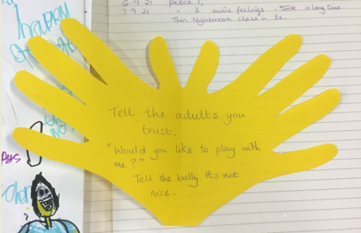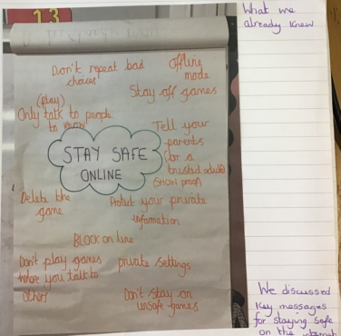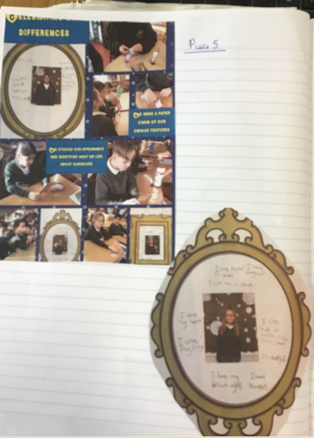
Puzzles will be launched with a whole-school assembly containing an original song. Because each year group will be studying the same unit at the same time (at their own level), learning will be built sequentially through the school year. The various teaching and learning activities are engaging and mindful of different learning styles and the need for differentiation and the Early Years (EYFS) planning is aligned to the National Early Years Framework (England). Lessons will be delivered in a creative manner and include discussions, role play and games. Each year, three of the Jigsaw themes will be chosen to have a whole school sharing assembly at the end of the unit, where each year group will show and explain their final piece to the rest of the school. Where appropriate, these final pieces will be made into a whole school display, to celebrate everyone’s achievements.

Each lesson is built upon a Charter which underpins the behaviour and respect that is the basis for each lesson. To ensure learning follows the optimum progression, each lesson follows a set structure.

Connect us - This is a game or activity designed to be fun and inclusive and to build and maximise social skills.

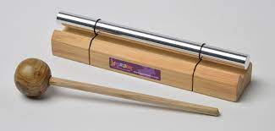
Calm me - This section of the Piece helps children gain awareness of the activity in their minds, relaxing them and quietening their thoughts and emotions to a place of optimum learning capacity.

Open my mind – This introduces the main teaching points of the lesson.

Tell me or show me - This is used to introduce new information, concepts and skills, using a range of teaching approaches and activities.

Let me learn - after receiving new information/concepts, children need to manipulate, use, and play with that new information in order for it to make sense to them and for them to ‘accommodate’ it into their existing learning.

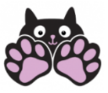
Help me reflect – Children are encouraged to reflect upon their learning. They are also asked to stop and become aware of their thoughts and feelings in any given moment in Pause Points - brief pauses within the lesson where the children can have a couple of moments to just stop and be to consider whether what they are learning may be particularly meaningful to them.

Closure - Each Piece needs safe closure. This will always include the teacher praising the pupils for their effort, positive attitude and achievement, as well as giving one or two sentences to summarise the key learning points.

Differentiation/SEN
Jigsaw is written as a universal core curriculum provision for all children. Inclusivity is part of its philosophy. Teachers will need, as always, to tailor each Piece (lesson) to meet the needs of the children in their classes. To support this differentiation, many Jigsaw Pieces (lessons) suggest creative learning activities that allow children to choose the media with which they work and give them scope to work to their full potential.

Additional Support
As needed, support is provided to pupils when they find particular topics more challenging and each class in KS2 has a worry box, in which children can share any concerns, whether they arise from the lesson or any other issue. In addition to worry boxes, each KS2 class also has an ‘ask-it basket’ where they will have the opportunity to independently ask questions, and compliment boxes. In EYFS and KS1 classes, there are ‘tell me’ boxes where the children can put in their name so a trusted adult in the class can touch base with them. These boxes form part of class reflective areas, which also help to make links with themes covered in Collective Worship and go hand in hand with our school values. (During Relationships and Changing Me lessons, the ‘ask it’ baskets will be kept on the teacher’s desk so children feel safe in adding a question). There may also be occasions where teachers feel it necessary to teach PSHE as a result of an issue that has arisen in their own class as we recognise that PSHE is integral to children’s development.


