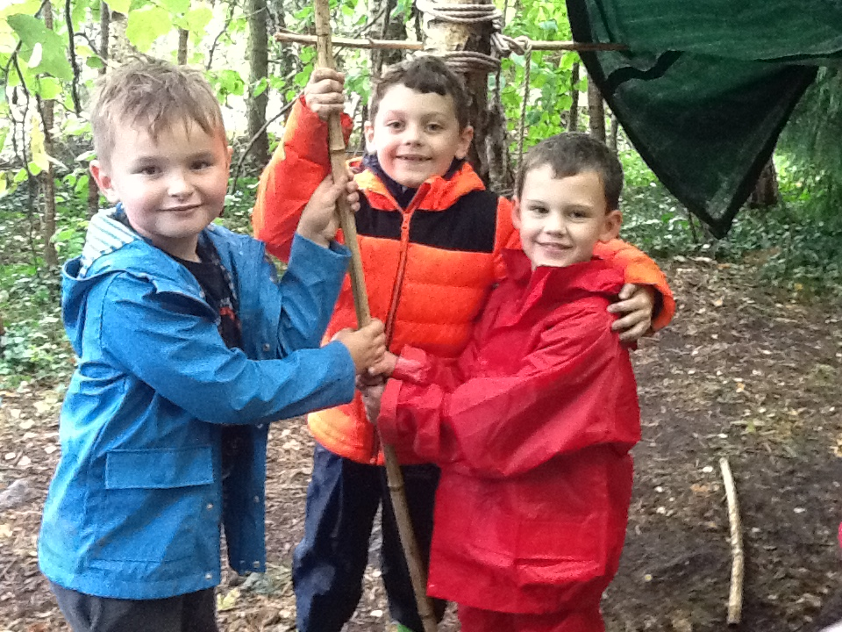

All About Forest School
The purpose of this booklet is to give you some information about our Forest School sessions. We want all parents/carers to feel at ease with what we do and also share our enthusiasm about it. If you have any questions at all, please feel free to ask. We have a Forest School handbook which contains all the detailed information and can be viewed if arranged with a member of staff.
What is Forest School?
Forest School is a long term outdoor program delivered by our trained Forest School Leader, Georgia Satchwell. The sessions take place within the natural environment in the school grounds, in all weathers except for unsafe weather conditions such as high winds or storms.
What do the children learn?
The ethos of Forest School is to allow children the time and space to develop skills, grow in confidence, take risks, build their self-esteem and gain an understanding of the natural world around them. It also allows staff to observe the children and encourage them to achieve the most from their learning.
The children are set an ‘achievable task’ each session, to spark their interest and use as a stepping stone for their own choice of learning.
Forest School is held within the school grounds, usually within the woodland areas near North Gate. There are two seating areas with a small fire circle and lots of space to explore.
Are the children safe?
Safety checks are carried out before the children use the site. The children are taught the safety rules from the start of the first session and these are repeated at every session. Ask your child what the safety rules are.
What do the children need to bring?
Children will come to school in their uniform and change into their Forest School clothes at the start of the session, so please make sure it is all labelled in a separate bag.
Things children need:
- Wellington boots or sturdy shoes (that can get muddy)
- Warm layers for the colder months - vests, socks, etc. Layers are better than one thick coat or jumper.
- Long sleeved tops should be worn throughout the year including the summer, this helps prevent nettle stings, bramble scratches and insect bites.
- Waterproof coat and trousers if possible, children are outside for around 2 hours.
- Warm hat and gloves when appropriate.
- Sun hat and suncream for hotter weather

Things to remember:
Children may get wet and muddy
Children may get stung by a nettle or an insect bite.
Children may have minor bumps and scrapes during their adventures at Forest School
There is no such thing as bad weather, only inappropriate clothing
There is always a First Aid kit and fully trained First Aider with the children in Forest School. Finally......it’s all about having fun!!!!


