MATHS AT NUNNERY WOOD PRIMARY SCHOOL
Our aim at NWPS is to develop a passion and a positive attitude towards mathematics. We promote enjoyment and enthusiasm for learning through practical activity, exploration and discussion and we aim to develop every individual's potential in mathematics by becoming independent, confident and logical thinkers with flexibility.
In September 2018, we became part of the GLOW (Gloucestershire, Oxfordshire and Worcestershire) maths hub. The GLOWMaths Hub is one of the network of DfE funded school-based centres designed to transform mathematics education. There are thirty-five hubs around the country. There are seven schools in our hub and we are led by a specialist from a primary school in Cheltenham.
Since joining the hub, we have adopted the mastery approach to teaching maths. Inspired by approaches developed in Singapore and Shanghai, mastery is an inclusive way of teaching that is grounded in the belief that all pupils can achieve in maths. A concept is mastered when learners can represent it in multiple ways; can communicate solutions using mathematical language and can independently apply the concept to new problems.
The Five ‘Big Ideas’ in Teaching for Mastery:

A central component in the NCETM/Maths Hubs programmes to develop Mastery Specialists has been discussion of Five Big Ideas, drawn from research evidence, underpinning teaching for mastery. This is the diagram used to help bind these ideas together:

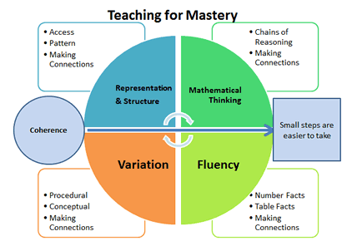

Coherence: Connecting new ideas to concepts that have already been understood, and ensuring that, once understood and mastered, new ideas are used again in next steps of learning, all steps being small steps

Representation and Structure: Representations used in lessons expose the mathematical structure being taught, the aim being that students can do the maths without recourse to the representation

Mathematical Thinking: If taught ideas are to be understood deeply, they must not merely be passively received but must be worked on by the student: thought about, reasoned with and discussed with others

Fluency: Quick and efficient recall of facts and procedures and the flexibility to move between different contexts and representations of mathematics

Variation: Varying the way a concept is initially presented to students, by giving examples that display a concept as well as those that do not display it. Also, carefully varying of practice questions, so that mechanical repetition is avoided and thinking is encouraged.

How is Maths Taught at NWPS?
Fluency Skills – To ensure children do not forget the basics as they move from one unit of Maths to another, we have added in some ‘Fluency Fun’ time every day to enable children to practise essential skills and facts, such as rapid recall of number bonds and tables facts that they have already been taught.

Daily Maths Lessons – Most aspects of the maths curriculum are taught through discrete Maths lessons. We use a mastery approach to teaching, which means that we focus on topics, such as place value or addition, for a longer period of time to enable pupils to gain a deeper understanding of the mathematical concepts. Children are given opportunities to develop fluency, reason mathematically and solve problems with our do it, twist it, deepen it lesson structure.

Cross-Curricular Maths – Some aspects of the maths curriculum are taught through a cross-curricular approach. There are strong links with Computing, Science, Geography, History, DT and Art.

Models and Images – To support children’s conceptual understanding, we use a range of models and images, including Numicon, straws, bead strings, place value counters, number lines, fraction boxes and Dienes’ apparatus.

Speaking and Listening – Reasoning is a key skill and lessons are planned carefully to develop the use of mathematical language (‘expert language’) as a means of communicating ideas and concepts.
Growth Mindset - Having a positive mindset is a key factor in lessons. Children are taught that it is fine to make mistakes (‘understandable mistakes’) as that is how we learn. They learn to persevere and never give up. Our Have-a-Go Heroes help children to remember this:

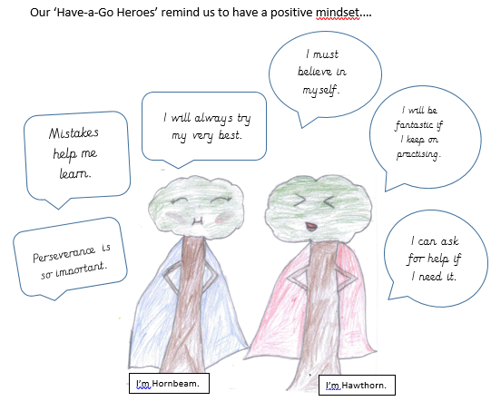

Enrichment
As a school, we are always looking at ways of promoting deep learning to challenge all children and we aim to offer some opportunities for children to engage in Maths beyond the classroom. Every year, some of our year 5 children take part in the King’s School Maths Challenge and some of our year 6 children enter the King’s School Primary Schools Quiz. This year, we held a very successful maths open morning on Number Day, which we invited parents to join us for.

We have subscriptions to Timestable Rock stars. Children can use this exciting platform both in school and at home to practice their times tables.

HELPING AT HOME

Home is an ideal place for children to apply the Maths they have learnt in school to real-life situations. Plenty of ideas are listed below:
- Talk about numbers in sport.
- When cooking, measure ingredients and set the timer together. Talk about fractions in cooking, for example ask them how many quarter cups make a whole cup.
- Discuss proportions when you make a cup of tea or squash. Ask them how much milk or how much water they are using.
- Talk about the shape and size of objects. Use the internet to find interesting facts like tallest and shortest people, or biggest and smallest buildings etc.
- Talk about time. For example, get them to work out what time you need to leave the house to get to school on time.
- Look for maths on TV, newspapers, magazines and talk about it together.
- Use newspapers. Talk to your child about percentages in special offers; the probability in the weather reports; the length of TV shows and compare house prices and order from cheapest to most expensive.
- Solve maths problems at home. For example, 'We have 3 pizzas cut into quarters, if we eat 10 quarters, how many will be left?’
- Talk about shape, size and quantity. Use the internet to find interesting size facts like most and least populated cities; highest mountains or deepest valleys, etc.

Maths and Money
Money is linked really closely to maths and developing financial literacy is really important with young children.
- If your child has a mobile phone, use it to talk about maths and money saving. Look together for the best plans - does their network sell any extras that would make texts or calls cheaper?
- At the shops, when buying a couple of items, ask them to work out how much they will cost together. As a challenge for older children, ask them to estimate what the weekly shop will come to. How much change for an item if I pay with a £5 note?
- Use pocket money as an opportunity to talk about maths – are they saving for anything? How much do they need to save each week to buy it?
- Work out offers in supermarkets together. Ask them to work out which are the best deals.
- When travelling, ask your child to help you work out whether it's cheaper to drive or take public transport. Are there any deals you can get on public transport?
- Talk to them about getting a bank account. Look together at what's on offer for young people opening their first account and see which is the best deal.
- Ask your child to check your change.

Games
Games are a great way to both engage children and get them to use their mathematical skills. Some ideas for maths use at home with games include:
- Play with cards. Take 2 cards and add the numbers together, the player with the highest number wins. Try it with subtraction, multiplication, and division too.
- Get them to design a tree house, clothes or car or whatever they're interested in. Ask them to work out the right measurements.
- Play board games like Connect 4, Jenga, Monopoly, Scrabble or Dominos.
- Ask your child to design their own board game and dice. Play the game together and talk about the mathematical thinking, reasoning, or problem solving the game used.

Out and About
Whether attending sporting events, walking around the local area or in the car, opportunities abound for teaching maths:
- When travelling somewhere familiar, ask your child to give you directions and timings, then test their directions out. If they get something wrong, ask them to think of the best way to get back to where you want to go.
- Look for patterns and symmetry when out and about.
- Sports are the perfect chance to think about speed, scores, time and angles. Get competitive; try out different angles to score from, ask them how many star jumps can they do in a minute.
- Explore the local area. Ask them to guess how many people live in your town, how far is the nearest airport is etc. Ask for the reasons behind their answer and check the answers online.
- Estimation. For example ask them to think about how they can estimate how many bricks were used to build a local landmark.
- Hobbies. Ask them to talk about the maths they have come across in the favourite hobby.
- Journeys. Ask them questions like how many miles or kilometres have we travelled, how many are left and what time should we get to our destination.
The following websites are great!
- Timestable Rockstars
- Hit the Button
- Primary Games
- Maths Zone
- Topmarks
- Multiple Wipeout

