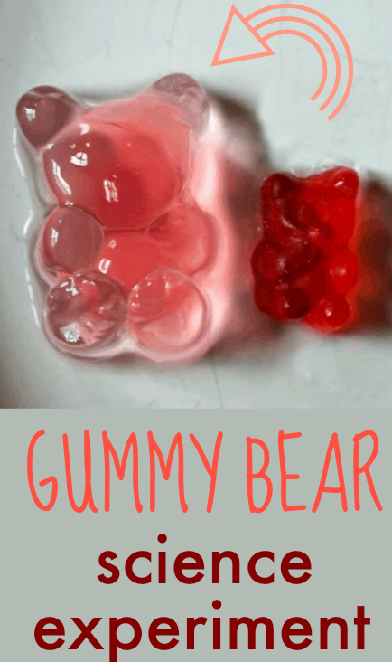
You will need:
Jelly Teddy Bears – Gummy Bears or similar
4 containers or cups
Water
Salt
Sugar
Vinegar
Before you start: Look closely at your jelly/gummy bears and hold them for a short time too (not too long to make them sticky!) Think about what they look like and how they feel before you begin our science investigation.
What to do:
- Put some water in each cup / container.

- Add a teaspoon of sugar to one cup of water, a teaspoon of salt to another cup and a tea spoon of vinegar to another cup. Leave one cup with plain water in.

- Stir the water to mix in the sugar, salt and vinegar. You might want to add a label for each cup to remember what is in each one.

- Add a jelly gummy bear to each cup and leave for several hours or overnight. What do you think will happen to the bear in each different solution? Make a prediction.

- Look at what has happened to the bears in each different water solution. How have they changed? What is different and what is the same? Why do you think the changes have happened?

Have fun!

